Assignment – 2

Q1. Create a table to display student information with the following fields and insert atleast two student details: Roll Number, Name, Email, Mobile Number, Profile Photo.
Code:
<html>
<head>
<title>Student Information Table</title>
<style>
table {
border-collapse: collapse;
width: 70%;
margin: 25px 0;
font-family: Arial, sans-serif;
}
th, td {
border: 1px solid;
text-align: left;
padding: 12px;
vertical-align: middle;
}
img {
width: 50px;
height: 50px;
}
</style>
</head>
<body>
<h2><u>Student Details</u></h2>
<table>
<thead>
<tr>
<th>Roll Number</th>
<th>Name</th>
<th>Email</th>
<th>Mobile Number</th>
<th>Profile Photo</th>
</tr>
</thead>
<tbody>
<tr>
<td>1001</td>
<td>A B De Villiers</td>
<td>abd@gmail.com</td>
<td>9876543210</td>
<td><img src="abd.png" alt="ABD"></td>
</tr>
<tr>
<td>2002</td>
<td>Mahendra Singh Dhoni</td>
<td>msd@gmail.com</td>
<td>876598231</td>
<td><img src="msd.avif" alt="MSD"></td>
</tr>
<tr>
<td>3003</td>
<td>Virat Kohli</td>
<td>vk@gmail.com</td>
<td>7894561230</td>
<td><img src="vk.jpg" alt="VK"></td>
</tbody>
</table>
</body>
</html>
Output:
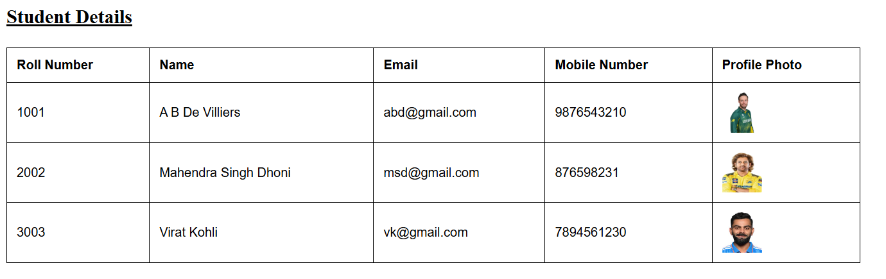

Q2. Design the following time table using HTML table tags and attributes only:
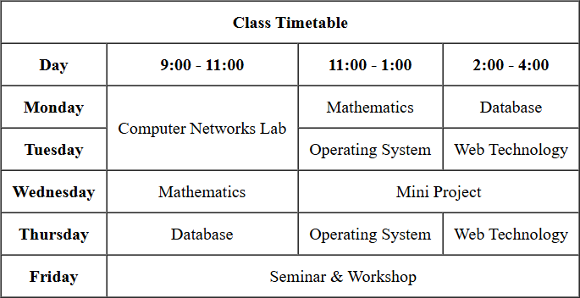

Code:
<html>
<head>
<title>TimeTable</title>
<style>
table {
border-collapse: collapse;
width: 70%;
margin: auto;
font-family: Arial, sans-serif;
}
th, td {
border: 1px solid;
text-align: center;
padding: 12px;
vertical-align: middle;
}
</style>
</head>
<body>
<h1><center><u>Time Table</u></center></h1>
<table align="center" width=800 height=200 border=1 cellpadding=5 >
<tr align="center">
<th colspan=4> Class TimeTable</th>
</tr>
<tr align="center">
<th>Day</th>
<th>9:00 - 11:00</th>
<th>11:00 - 1:00</th>
<th>2:00 - 4:00</th>
</tr>
<tr align="center">
<td><b>Monday</b></td>
<td rowspan=2>Compuer Networks Lab</td>
<td>Mathematics</td>
<td>Database</td>
</tr>
<tr align="center">
<td><b>Tuesday</b></td>
<td>Operating System</td>
<td>Web Technology</td>
</tr>
<tr align="center">
<td><b>Wednesday</b></td>
<td>Mathematics</td>
<td colspan=2>Mini Project</td>
</tr>
<tr align="center">
<td><b>Thursday</b></td>
<td>Database</td>
<td>Operating System</td>
<td>Web Technology</td>
</tr>
<tr align="center">
<td><b>Friday</b></td>
<td colspan=3>Seminar & Workshop</td>
</tr>
</table>
</body>
</html>
Output:
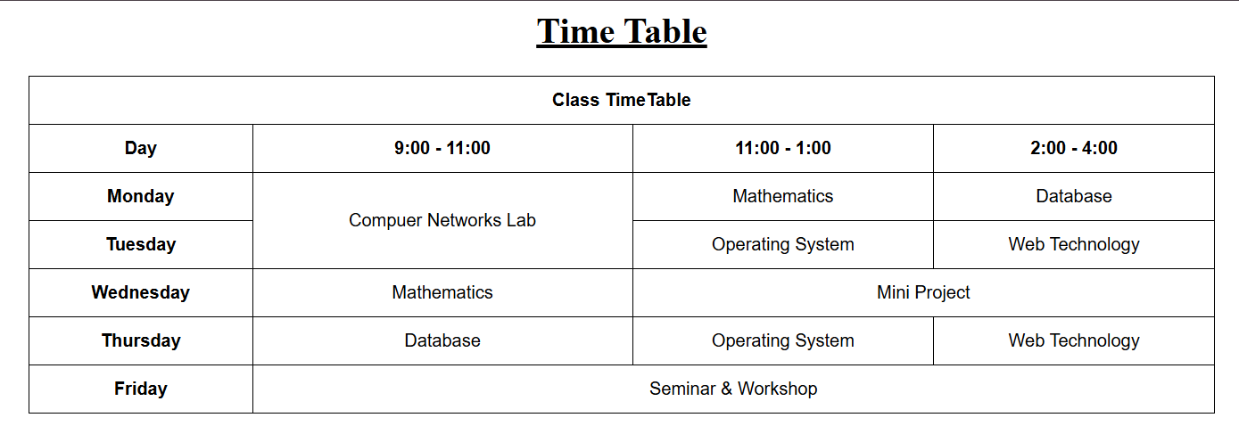

Q3. Create a registration form for an online course with the following fields:
o Full Name(text)
o Email(text)
o Password and Confirm Password(password)
o Gender(radio buttons :Male, Female, Other)
o Date of Birth(date picker)
o Course(drop down: B.Tech, M.Tech, MCA ,MBA)
o Skills(checkboxes: HTML, CSS, JavaScript, Python, Java)
o Address(text area)
o Upload Resume(file input)
o Submit and Reset buttons
Code:
<html>
<head>
<title>Online Registration Form</title>
</head>
<body>
<h2> Online Registration Form</h2>
<form>
Full Name: <input type="text" name="fullname"><br><br>
Email: <input type="email" name="email"><br><br>
Password: <input type="password" name="password"><br><br>
<p>Select your Gender:</p>
<input type="radio" id="male" name="gender" value="male">
<label for="male"> Male</label><br>
<input type="radio" id="female" name="gender" value="female">
<label for="female"> Female</label><br>
<input type="radio" id="other" name="gender" value="other">
<label for="other"> Other</label><br><br>
<p>Select your Date of Birth:</p>
<input type="date" name="dob"><br><br>

<label for="course">Choose a Course:</label>
<select id="course" name="Course">
<option value="btech">B.TECH</option>
<option value="mtech">M.TECH</option>
<option value="mca">MCA</option>
<option value="mba">MBA</option>
</select><br><br>

<p>Select your interests:</p>
<input type="checkbox" id="interest1" name="interest1" value="html">
<label for="interest1"> HTML</label><br>
<input type="checkbox" id="interest2" name="interest2" value="css">
<label for="interest2"> CSS</label><br>
<input type="checkbox" id="interest3" name="interest3" value="javascript">
<label for="interest3"> JavaScript</label><br>
<input type="checkbox" id="interest4" name="interest4" value="python">
<label for="interest4"> Python</label><br>
<input type="checkbox" id="interest5" name="interest5" value="java">
<label for="interest5"> Java</label><br><br>

Address:<textarea rows="4" cols="40"></textarea><br><br>

Upload Resume:<input type="file"><br><br>

<input type="submit" value="Submit"><br><br>
<input type="reset" value="Reset"><br>
</form>
</body>
</html>
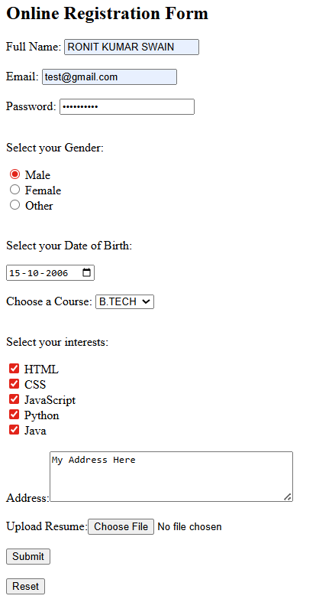
Output:

Q4. Create a webpage that demonstrates multimedia integration:
a. Embed an audio file with controls(play/pause).
b. Embed a video file with controls.
Code:
<html>
<head>
<title>Mutimedia Integration</title>
</head>
<body bgcolor="Cornsilk" >
<center>
<h1>Multimedia Integration</h1>
<h2><u>Audio Player</u><h2>
<audio controls>
<source src="beast_bgm.mp3" type="audio/mpeg">
</audio>
<h2><u>Video Player</u><h2>
<video width="630" height="420" controls autoplay loop muted>
<source src="samplevideo.mp4" type="video/mp4">
</video>
<center>
</body>
</html>
Output:
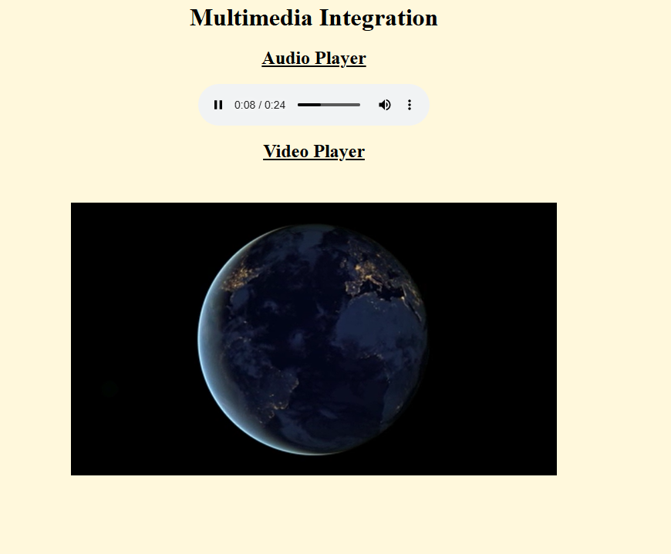
Q5. Create a webpage named My Profile using HTML5 semantic elements. Your page must
use appropriate semantic tags (for example: <header>, <nav>, <main>, <section>,
<footer>) and must satisfy all of the following requirements:
a. Use a <nav> with anchor links (bookmarks) to the sections on the same page: About,
Education, and Hobbies.
b. Use a <header> element that contains your name as the main heading (<h1>), your
phone number and your email.
c. Use a <main> element to wrap the primary page content.
d. Create three <section> elements with id attributes about, education, and hobbies.
Each section must have a heading (<h2>) and atleast one paragraph describing the
topic.
e. In the about section, Include your profile image and a paragraph about yourself. Use
a list to showcase your skills.
f. In the education section, use a table to showcase your academic records.
g. In the hobbies section, add a list of hobbies.
h. The footer section must contain hyperlinks to your social media handles.
Code:
<html>
<head>
<title>My Profile</title>
</head>
<body>
<nav>
<a href="#about">About</a> |
<a href="#education">Education</a> |
<a href="#hobbies">Hobbies</a>
</nav>

<header>
<h1>Name: Ronit Kumar Swain</h1>
<p>Phone no: <u>9876543210</u></p>
<p><a href="mailto:kumarswainronit@gmail.com">kumarswainronit@gmail.com</a></p>
</header>

<main>
<section id="about">
<h2>About</h2>
<img src="https://erp.silicon.ac.in/uploads/student_photo/SITBBS_B.TECH_2024-2028/CSE/24BCSH03/24BCSH03_64X64.jpg">
<p>
I am a student who is interested in learning new technologies and improving my skills in
programming and web development.<br> I enjoy understanding how things work behind the
scenes and like experimenting with code to build simple and easy projects.
</p>
<h3>Skills</h3>
<ul>
<li>HTML</li>
<li>Basic C</li>
<li>Basic Python Programming</li>
<li>Problem Solving</li>
<li>Basic Java Programming</li>
<li>Basic Web Design</li>
</ul>
</section>

<section id="education">
<h2>Education</h2>
<p>
I am currently pursuing my studies in Computer Science and Engineering at Silicon University, Bhubaneswar. <br>
</p>
<table border="1" cellpadding="8" cellspacing="0">
<tr>
<th>Qualification</th>
<th>Institution</th>
<th>Year</th>
<th>Very Remarks</th>
</tr>
<tr>
<td>High School</td>
<td>SSVM</td>
<td>2022</td>
<td>Good</td>
</tr>
<tr>
<td>Higher Secondary School</td>
<td>BJB HSS</td>
<td>2024</td>
<td>ok ok</td>
</tr>
<tr>
<td>Undergraduate (Pursuing)</td>
<td>Silicon University</td>
<td>2028</td>
<td>-</td>
</tr>
</table>
</section>

<section id="hobbies">
<h2>Hobbies</h2>
<p>
In my free time, I enjoy exploring new technologies, coding, and learning about computers. <br>
I also like playing different Mobile and Computer games and spending time online discovering new ideas and content.
</p>
<ul>
<li>Coding and learning new programming concepts</li>
<li>Playing Games like: Cricket, Badminton etc.</li>
<li>Playing video games</li>
<li>Exploring new technologies</li>
<li>Listening to music</li>
</ul>
</section>
</main>
<footer>
<h2>Social Media</h2>
<p>
<b>Connect With Me:</b><br><br>
<a href="https://github.com/Ronit-kumar-swain-07" target="_blank">GitHub</a> |
<a href="https://www.linkedin.com/in/ronit-kumar-swain-3b94a3303/" target="_blank">LinkedIn</a> |
<a href="https://www.geeksforgeeks.org/profile/kumarswainronit?tab=overview" target="_blank">GeeksForGeeks</a> |
<a href="https://x.com/RONITKUMARSWAIN" target="_blank">X</a> |
</p>
</footer>
</body>
</html>
Output:
